How to disable the driver enforcement for the Ultra Serial or LYYN FTDI with W8 or W10
Windows 10/8:
- Type Advanced Recovery into the Windows Search Bar.
- Under Advanced Startup select restart now.
- Now it will enter the advanced startup screen.
- Choose an Option : Troubleshoot
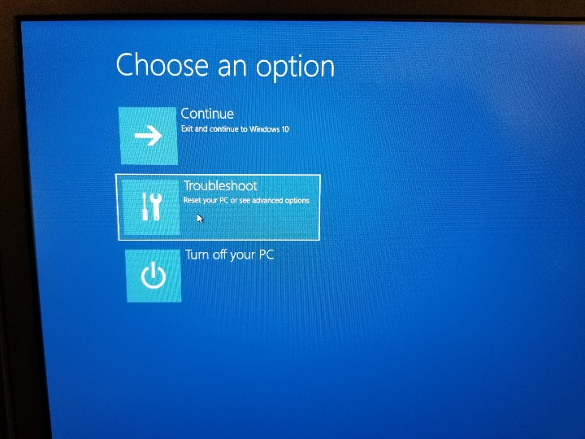
- Select Advanced Options: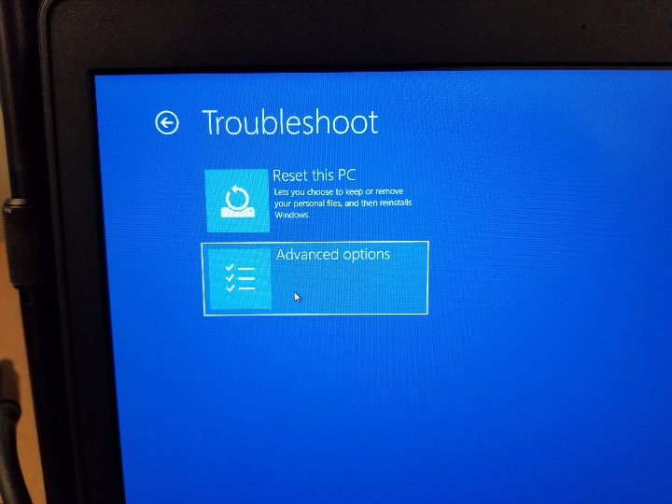
- Select See More Recovery Options:

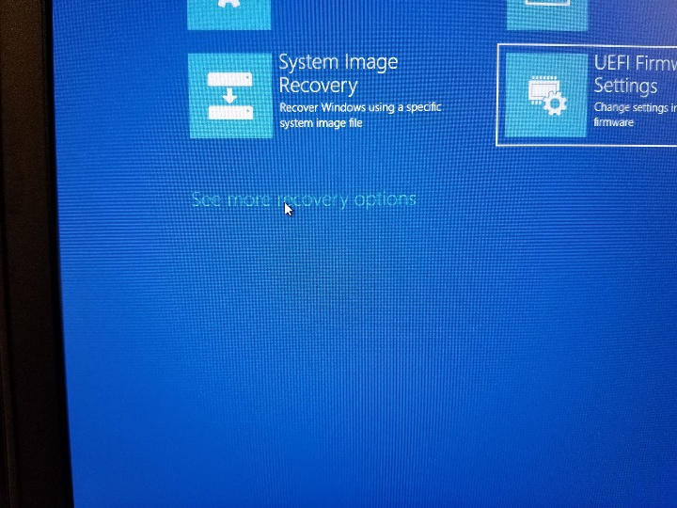

- Select Startup Settings:
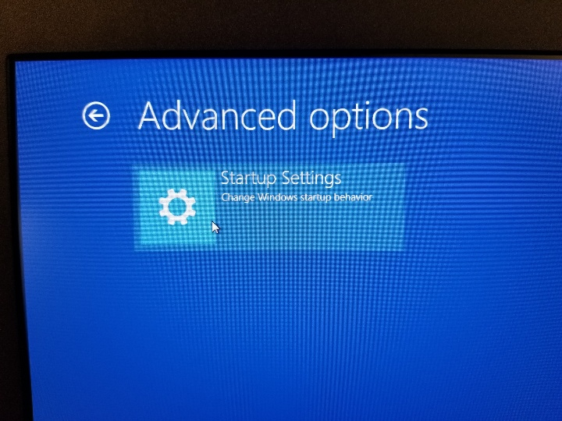

- Select the Restart button:
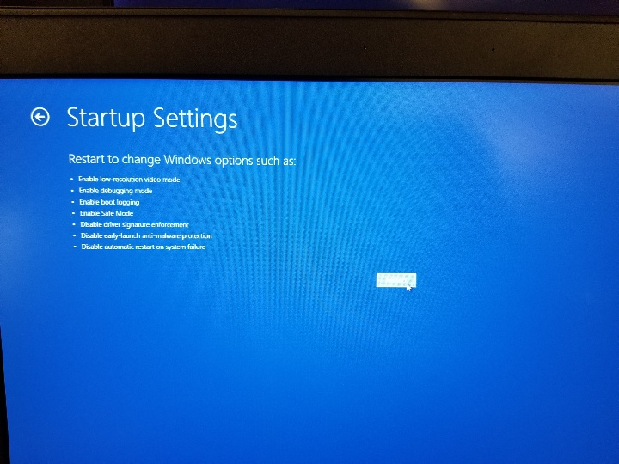
- The computer will restart and take you to the next screen prompt.
- Press 7 to Disable Driver Enforcement: 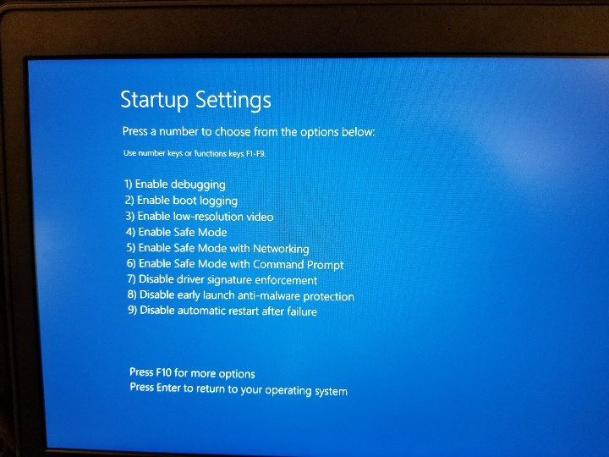

- The computer will then restart back to the Windows desktop screen.
- The Ultra and LYYN Hawk drivers can be found at
  - C:/VideoRay/Installs
  - Our website:
  - https://videoray.com/support/downloads.html
- You’ll need to be unzip the folder before running the setup if you download the driver from the VideorRay website.
- Run the setup (LYYN Hawk or Ultra Panel driver) depending on what’s required.
  - The driver will ask you to install twice.
  - Once the installer is done, the device should be working properly.

